Windows DevOps Environment Setup Guide

For any installation-related challenges, or if you get stuck at any point, you can book a session with the faculty for support.

For DevOps Learners:
Mohan: https://calendly.com/kandikuppa-krishna-herovired/30min
Chirag Goyal: https://calendly.com/chirag-goyal-herovired/30min

How to Book:

Click on the link of your preferred mentor
Select an available date and time
Confirm your booking
You will receive a calendar invite with the meeting details

Please ensure you book only one session at a time and choose the mentor based on the topic you want to discuss. We encourage you to come prepared with your questions to make the most of the session.

–
Complete step-by-step guide to setting up a professional DevOps toolchain on Windows using Chocolatey as the package manager.
Before you begin: You need Windows 10 (version 2004 or later) or Windows 11. Open PowerShell as Administrator for all commands — right-click the Start button → Windows PowerShell (Admin) or Terminal (Admin).

1. Install Chocolatey (Package Manager)
Chocolatey is the Windows equivalent of apt (Linux) or brew (macOS). It lets you install, update, and manage software from the command line — no manual downloads, no clicking through installation wizards. Every tool in this guide installs with a single choco install command.

Step 1 — Allow PowerShell to run scripts
Set-ExecutionPolicy Bypass -Scope Process -Force

Step 2 — Install Chocolatey
[System.Net.ServicePointManager]::SecurityProtocol = [System.Net.ServicePointManager]::SecurityProtocol -bor 3072; iex ((New-Object System.Net.WebClient).DownloadString('https://community.chocolatey.org/install.ps1'))

Step 3 — Close and reopen PowerShell as Administrator, then verify
choco --version
# Expected output: 2.x.x
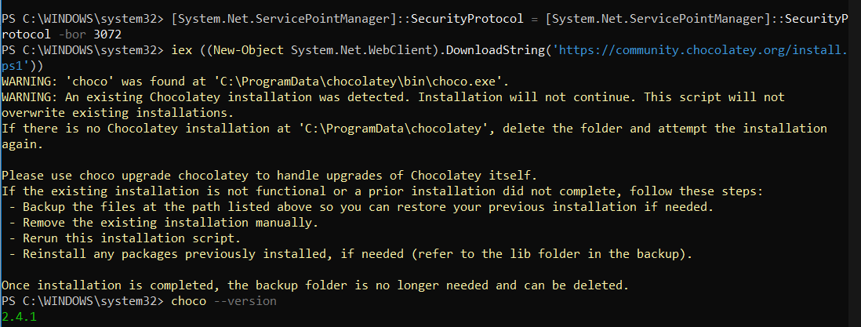
If you see a version number, Chocolatey is ready. From now on every install uses choco install <package> -y

2. Install Visual Studio Code

Install via Chocolatey
choco install vscode -y

Verify
code --version

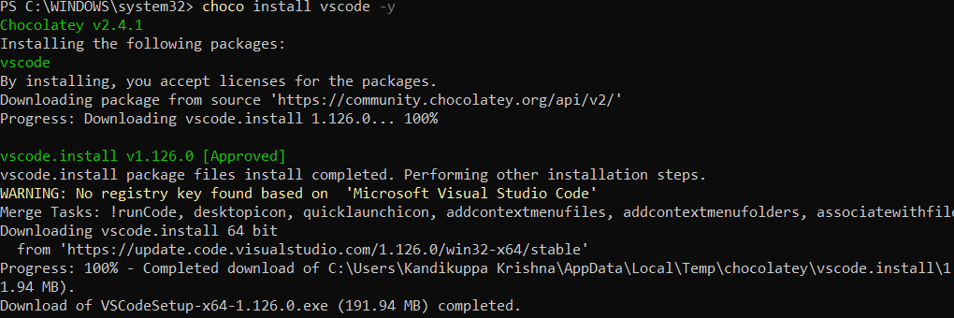

Install Essential DevOps Extensions
Run these commands in PowerShell — they install VS Code extensions silently:
# Python support
code --install-extension ms-python.python

# Docker support
code --install-extension ms-azuretools.vscode-docker

# Terraform support
code --install-extension hashicorp.terraform

# Remote WSL development
code --install-extension ms-vscode-remote.remote-wsl

# GitLens — git history inside the editor
code --install-extension eamodio.gitlens

# YAML (for Kubernetes / Docker Compose files)
code --install-extension redhat.vscode-yaml

You can also install extensions from inside VS Code — press Ctrl + Shift + X to open the Extensions panel and search by name.

3. Install Python 3

Install via Chocolatey
choco install python3 -y

Restart the terminal, then verify
python --version
pip --version

Upgrade pip to the latest version
python -m pip install --upgrade pip

Test Python works
python -c "import sys; print(sys.version)"

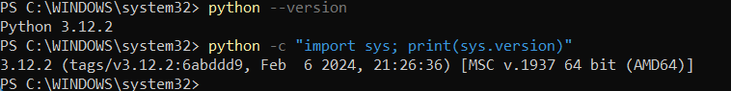
If python is not found after install, close PowerShell completely and reopen it as Administrator. Chocolatey updates the PATH but the current session won't see it until restarted.

4. Install WSL 2 (Windows Subsystem for Linux)
WSL 2 runs a real Linux kernel inside Windows. It is essential for DevOps workflows — most cloud tools, scripts, and documentation assume a Linux environment.
Requirements: Windows 10 version 2004 (Build 19041+) or Windows 11. Virtualisation must be enabled in your BIOS/UEFI settings.

Step 1 — Install WSL 2 and Ubuntu in one command
wsl --install

This single command installs WSL 2, the Linux kernel update, and Ubuntu (default distro). Restart your PC when prompted.

Step 2 — Set up your Linux user
After the restart, Ubuntu opens automatically. You will be prompted to create a Linux username and password — this is separate from your Windows login.

Step 3 — Set WSL 2 as the default version and update
# Set WSL 2 as default
wsl --set-default-version 2

# Update the WSL kernel
wsl --update

# Verify
wsl --list --verbose
# Expected: Ubuntu Running 2

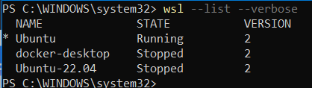

Step 4 — Update Ubuntu packages
Open a WSL/Ubuntu terminal (type wsl in PowerShell) and run:
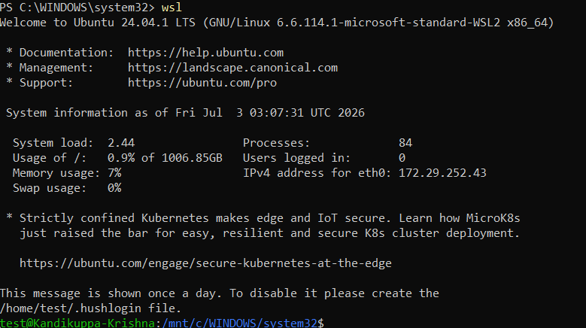
sudo apt update && sudo apt upgrade -y

Open WSL anytime by typing wsl in PowerShell, launching Ubuntu from the Start Menu, or clicking the dropdown arrow in Windows Terminal.

5. Install Git & Set Up GitHub

Install Git via Chocolatey
choco install git -y

Verify
git --version
# Expected: git version 2.x.x.windows.x
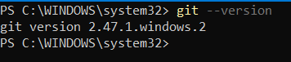

Configure Git Identity
# Replace with your actual name and email
git config --global user.name "Your Name"
git config --global user.email "you@example.com"
git config --global core.editor "code --wait"
git config --global init.defaultBranch main

# Verify
git config --list
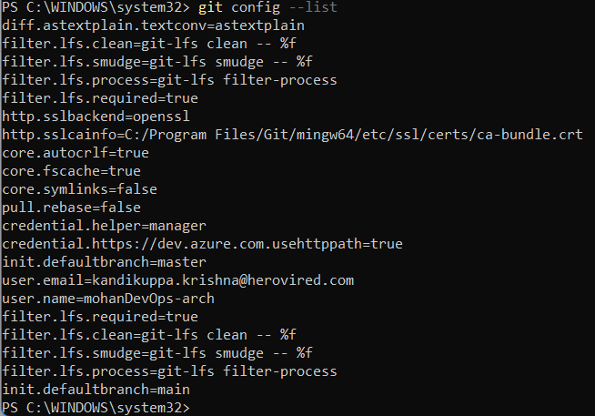

Create a GitHub Account
- Go to github.com and click Sign Up
- Choose a username, enter your email, and create a password
- Verify your email address when prompted

Connect to GitHub via SSH
# Generate an SSH key (replace with your GitHub email)
ssh-keygen -t ed25519 -C "you@example.com"
# Press Enter to accept the default file location
# Optionally set a passphrase for extra security

# Display your public key — copy this entire output
Get-Content ~/.ssh/id_ed25519.pub

Add the key to GitHub:
- Log in to GitHub → Settings → SSH and GPG keys → New SSH key
- Paste the public key you copied above → click Add SSH key

Test the SSH connection
ssh -T git@github.com
# Expected: Hi username! You've successfully authenticated...

6. Install Docker Desktop
Docker Desktop requires WSL 2 (Step 4) to be installed first. Complete Step 4 before running this command.

Install via Chocolatey
choco install docker-desktop -y

Post-install steps
- Restart your computer
- Launch Docker Desktop from the Start Menu
- Accept the Terms of Service on first run
- In Docker Desktop → Settings → General, confirm "Use the WSL 2 based engine" is checked

Verify Docker works
docker --version
docker-compose --version

# Run a test container
docker run hello-world

If you see "Hello from Docker!" — Docker is fully working.

7. Install Terraform

Install via Chocolatey
choco install terraform -y

Verify
terraform --version
# Expected: Terraform v1.x.x on windows_amd64

Smoke test
mkdir tf-test
cd tf-test
# Create a minimal Terraform config
echo 'terraform { required_version = ">= 1.0" }' > main.tf
terraform init
# Expected: Terraform has been successfully initialized!

cd ..
rmdir /s /q tf-test
To update Terraform in the future: choco upgrade terraform -y
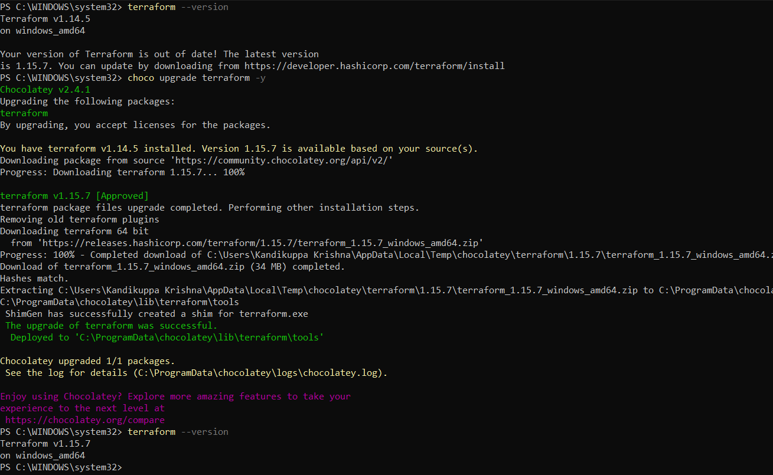

8. Install MongoDB

Install MongoDB Server, Shell, and Compass GUI
# MongoDB Community Edition (database server)
choco install mongodb -y

# MongoDB Shell (mongosh — command-line client)
choco install mongosh -y

# MongoDB Compass (visual GUI)
choco install mongodb-compass -y

Start MongoDB as a Windows service
# Start the service
net start MongoDB

# Verify it's running
mongosh --eval "db.runCommand({ connectionStatus: 1 })"

Connect with MongoDB Compass
- Open MongoDB Compass from the Start Menu
- Use the default connection string in the connection dialog:
mongodb://localhost:27017

- Click Connect — you should see the database panel on the left
💡 Useful service commands:
- Stop MongoDB: net stop MongoDB
- Enable auto-start: sc config MongoDB start= auto

9. Networking Tools in WSL (Linux)
Open your WSL/Ubuntu terminal (wsl in PowerShell) for all commands in this section.

Install all networking tools at once
sudo apt update && sudo apt install -y curl wget net-tools iputils-ping nmap traceroute dnsutils iproute2 telnet netcat-openbsd tcpdump htop jq tree vim git unzip zip ca-certificates software-properties-common apt-transport-https

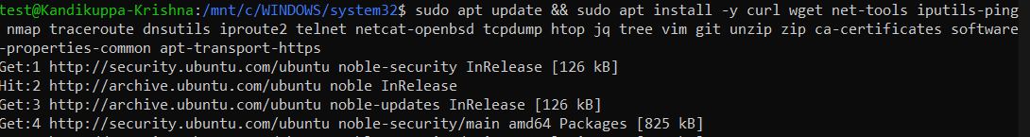

Networking Command Quick Reference
Command | What It Does | Example
ip addr | Show IP addresses for all interfaces | ip addr show eth0
ping | Test connectivity to a host | ping google.com
curl | Make HTTP requests | curl https://api.example.com
wget | Download a file | wget https://example.com/file.zip
nmap | Scan open ports on a host | nmap -sV localhost
traceroute | Trace the network path to a host | traceroute google.com
dig | DNS lookup | dig github.com
nslookup | Simple DNS query | nslookup google.com
ss -tuln | Show all listening ports | ss -tuln
netstat -an | Show all connections and ports | netstat -an | grep LISTEN
tcpdump | Capture live network packets | sudo tcpdump -i eth0
nc | Test if a port is open | nc -zv google.com 443
ifconfig | Show network interface config | ifconfig eth0

10. Final Verification Checklist

Run all checks in one PowerShell script
Write-Host "`n===== Windows DevOps Environment Check =====" -ForegroundColor Cyan

$checks = @{
"Chocolatey" = "choco --version"
"VS Code" = "code --version"
"Python" = "python --version"
"pip" = "pip --version"
"Git" = "git --version"
"Docker" = "docker --version"
"Terraform" = "terraform --version"
}

foreach ($tool in $checks.Keys) {
try {
$result = Invoke-Expression $checks[$tool] 2>&1 | Select-Object -First 1
Write-Host " ✅ $tool : $result" -ForegroundColor Green
} catch {
Write-Host " ❌ $tool : NOT FOUND" -ForegroundColor Red
}
}

Write-Host "`n Checking WSL..." -ForegroundColor Cyan
wsl --list --verbose

Individual verification commands
Tool | Command | Expected Output
Chocolatey | choco --version | 2.x.x
VS Code | code --version | 1.x.x
Python | python --version | Python 3.x.x
pip | pip --version | pip 2x.x ...
Git | git --version | git version 2.x.x
Docker | docker run hello-world | Hello from Docker!
Terraform | terraform --version | Terraform v1.x.x
MongoDB | mongosh --version | 2.x.x
WSL | wsl --list --verbose | Ubuntu with VERSION 2

Keep everything updated
# Update all Chocolatey packages in one command
choco upgrade all -y

Official Documentation Links
Tool | Documentation
Chocolatey | https://docs.chocolatey.org
Visual Studio Code | https://code.visualstudio.com/docs
Python | https://docs.python.org/3
WSL | https://learn.microsoft.com/en-us/windows/wsl
Git | https://git-scm.com/doc
GitHub | https://docs.github.com
Docker | https://docs.docker.com
Terraform | https://developer.hashicorp.com/terraform/docs
MongoDB | https://www.mongodb.com/docs

Windows DevOps Setup Guide — Built for PPMCAD

